**Q - 1 : WHAT IS DBMS, EXPLAIN FEATURES OF DBMS**

ANS -> **DBMS** : database management system (or DBMS) is essentially nothing more than a computerized data-keeping system. Users of the system are given facilities to perform several kinds of operations on such a system for either manipulation of the data in the database or the management of the database structure itself.

**FEATURES OF DBMS**

**Minimum Redundancy and Duplication**

Because databases are used by so many people, the risks of data duplication are relatively high. But in a database management system, data files are shared which brings down data duplication and redundancy. Due to the fact that all information in a database management system occurs only once, the odds of duplication are quite low. In other words, the same data file is accessible to all the people using the database, and the changes made by any one of the users get reflected for the data file of all the users and therefore, redundancy and duplication are avoided.

**Reduced amount of space and money spent on storage**

All database management systems must save a large amount of data. However, proper data integration saves a lot of space in the database management system. Companies spend a lot of money to keep their data safe. They will save money on data storage and data entry if they have managed data to store.

**Data Organization**

In a Database Management system, a digital repository’s information is structured in a clear hierarchical structure using records, tables, and objects. Every piece of information which we enter into our database will be structured in a catalog, making it easy to search and edit our records later.

**Customization of the Database**

Along with the default and required components (records, tables, or objects) that make up a database’s structure, custom elements can be constructed to fit the demands of unique users. For example, Binary Large Objects or BLOBS can be used to store images in databases and mappings can be maintained between various tables to implement complex entities.

**Data Retrieval**

The database management system, or DBMS, accepts and stores data from users. Users can subsequently get their records from the database and save them as a file, print them, or display them on the screen. Data Retrieval becomes a big advantage of the database management systems as only authenticated users can fetch data from the database and unauthenticated users are denied access, thus improving the security of the data.

**Usage Of Query Languages**

A typical Database Management System allows users to utilize query languages for collecting, searching, sorting, altering, and other tasks that enable them to manipulate their database entries. An example of a famous query language is SQL (Structured Query Language). Anyone, even without the knowledge of any programming language, can access a Database Management System easily without hassle.

**Multi User Access**

Multiple users can access all forms of information contained in the same data store with a Multi-User Access Database Management System. A security feature additionally restricts some users from seeing and/or altering specific data types and only authenticated users can access the database.

**Data Integrity is Maintained**

Multiple users can access all information in a database, but only one user can edit the same piece of data at a time. This feature allows you to avoid database corruption and failure and ensures that the Integrity of Data is maintained.

**Management of Metadata**

Metadata is “data that provides information about other data”, but not the content of the data, such as the text of a message or the image itself. The metadata library (or data dictionary) in DBMS database management software explains how the database is organized and what parts (objects, associated files, records, and so on) make up its structure.

**Maintenance of a Large Database**

Only a database management system can keep large databases of large corporations up to date. These databases necessitate a high level of security as well as backup and recovery capabilities. Database Management System includes all of these functionalities. It has the ability to keep a database with a large amount of data and information.

**Data Durability**

All data files are permanently stored by Database Management System, so there is no risk of data loss. If the data is lost, the organization’s data files can be saved using a backup and recovery procedure. As a result, there is no need to be concerned about data loss in Database Management Systems.

**Provides a High Level of Data Security**

All companies that handle a substantial volume of data are concerned about security. Except for the Database Administrator or the department head, Database Management Systems does not grant complete database access. They have the ability to change the database and create all of the users, therefore the database management system’s security level is increased.

**Enhanced File Uniformity**

Any business can build a homogeneous way to implement files and validate data uniformity with any other application programmes or systems by using the Database Management Systems. It is critical to rationalize and govern modern data management systems. A progressive database system’s application software enables the application of the same rules to all data across the organization.

**Q - 2: EXPLAIN DDL, DML , DQL COMMAND WITH EXAMPLE.**

ANS ->

**DDL (Data Definition Language):**

DDL or Data Definition Language actually consists of the SQL commands that can be used to define the database schema. It simply deals with descriptions of the database schema and is used to create and modify the structure of database objects in the database.DDL is a set of SQL commands used to create, modify, and delete database structures but not data. These commands are normally not used by a general user, who should be accessing the database via an application.

**List of DDL commands:**

**CREATE** : This command is used to create the database or its objects (like table, index, function, views, store procedure, and triggers).

**DROP**: This command is used to delete objects from the database.

**ALTER**: This is used to alter the structure of the database.

**TRUNCATE**: This is used to remove all records from a table, including all spaces allocated for the records are removed.

**COMMENT**: This is used to add comments to the data dictionary.

**RENAME**: This is used to rename an object existing in the database.

DML(Data Manipulation Language):

The SQL commands that deals with the manipulation of data present in the database belong to DML or Data Manipulation Language and this includes most of the SQL statements. It is the component of the SQL statement that controls access to data and to the database. Basically, DCL statements are grouped with DML statements.

**List of DML commands:**

**INSERT**: It is used to insert data into a table.

**UPDATE**: It is used to update existing data within a table.

**DELETE**: It is used to delete records from a database table.

**LOCK** :Table control concurrency.

**CALL**: Call a PL/SQL or JAVA subprogram.

**EXPLAIN PLAN**: It describes the access path to data.

**DQL (Data Query Language):**

DQL statements are used for performing queries on the data within schema objects. The purpose of the DQL Command is to get some schema relation based on the query passed to it. We can define DQL as follows it is a component of SQL statement that allows getting data from the database and imposing order upon it. It includes the SELECT statement. This command allows getting the data out of the database to perform operations with it. When a SELECT is fired against a table or tables the result is compiled into a further temporary table, which is displayed or perhaps received by the program i.e. a front-end.

**List of DQL:**

**SELECT**: It is used to retrieve data from the database.

**Q - 3 : EXPLAIN STRUCTURE OF DBMS.**

ANS -> Database Management System (DBMS) is software that allows access to data stored in a database and provides an easy and effective method of –

* Defining the information.
* Storing the information.
* Manipulating the information.
* Protecting the information from system crashes or data theft.
* Differentiating access permissions for different users.

**Data Theft**: When somebody steals the information stored on databases, and servers, this process is known as Data Theft.

*The database system is divided into three components: Query Processor, Storage Manager, and Disk Storage. These are explained as following below.*

**1. Query Processor:** It interprets the requests (queries) received from end user via an application program into instructions. It also executes the user request which is received from the DML compiler.

Query Processor contains the following components –

* DML Compiler: It processes the DML statements into low level instruction (machine language), so that they can be executed.
* DDL Interpreter: It processes the DDL statements into a set of table containing meta data (data about data).
* Embedded DML Pre-compiler: It processes DML statements embedded in an application program into procedural calls.
* Query Optimizer: It executes the instruction generated by DML Compiler.

**2. Storage Manager**: Storage Manager is a program that provides an interface between the data stored in the database and the queries received. It is also known as Database Control System. It maintains the consistency and integrity of the database by applying the constraints and executing the DCL statements. It is responsible for updating, storing, deleting, and retrieving data in the database.

It contains the following components –

* Authorization Manager: It ensures role-based access control, i.e,. checks whether the particular person is privileged to perform the requested operation or not.
* Integrity Manager: It checks the integrity constraints when the database is modified.
* Transaction Manager: It controls concurrent access by performing the operations in a scheduled way that it receives the transaction. Thus, it ensures that the database remains in the consistent state before and after the execution of a transaction.
* File Manager: It manages the file space and the data structure used to represent information in the database.
* Buffer Manager: It is responsible for cache memory and the transfer of data between the secondary storage and main memory.

**3. Disk Storage**: It contains the following components –

* Data Files: It stores the data.

* Data Dictionary: It contains the information about the structure of any database object. It is the repository of information that governs the metadata.
* Indices: It provides faster retrieval of data item.

**Q - 4 : WHAT IS ER DIAGRAM, ALSO EXPLAIN SYMBOLS OF ER DIAGRAM.**

ANS -> An entity relationship diagram (ERD), also known as an entity relationship model, is a graphical representation that depicts relationships among people, objects, places, concepts or events within an information technology (IT) system.

<https://www.lucidchart.com/pages/ER-diagram-symbols-and-meaning>

**Q - 5: EXPLAIN MAPPING CONSTRAINT.**

ANS ->

**Mapping Constraints**

* A mapping constraint is a data constraint that expresses the number of entities to which another entity can be related via a relationship set.
* It is most useful in describing the relationship sets that involve more than two entity sets.
* For binary relationship set R on an entity set A and B, there are four possible mapping cardinalities. These are as follows:

1. One to one (1:1)
2. One to many (1:M)
3. Many to one (M:1)
4. Many to many (M:M)

**One-to-one**

In one-to-one mapping, an entity in E1 is associated with at most one entity in E2, and an entity in E2 is associated with at most one entity in E1.

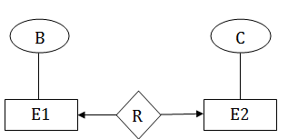

**One-to-many**

In one-to-many mapping, an entity in E1 is associated with any number of entities in E2, and an entity in E2 is associated with at most one entity in E1.

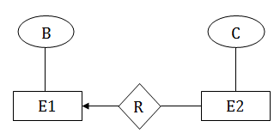

**Many-to-one**

In one-to-many mapping, an entity in E1 is associated with at most one entity in E2, and an entity in E2 is associated with any number of entities in E1.

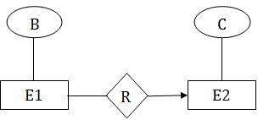

**Many-to-many**

In many-to-many mapping, an entity in E1 is associated with any number of entities in E2, and an entity in E2 is associated with any number of entities in E1.

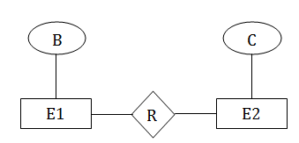

**Q - 6 : EXPLAIN KEY CONSTRAINTS.**

ANS ->

**Integrity Constraints**

Integrity constraints are a set of rules. It is used to maintain the quality of information.

Integrity constraints ensure that the data insertion, updating, and other processes have to be performed in such a way that data integrity is not affected.

Thus, integrity constraint is used to guard against accidental damage to the database.

Types of Integrity Constraint

**Key constraints**

* Keys are the entity set that is used to identify an entity within its entity set uniquely.
* An entity set can have multiple keys, but out of which one key will be the primary key. A primary key can contain a unique and null value in the relational table.

Example:

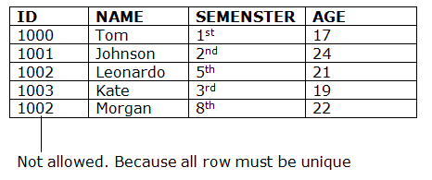

**Q -7 : DRAW ER DIAGRAM FOR FOLLOWING SYSTEM :**

1. **E-SCHOOL**
2. **E-COMMERCE**
3. **HOTEL MANAGEMENT.**

ANS ->

1. E-SCHOOL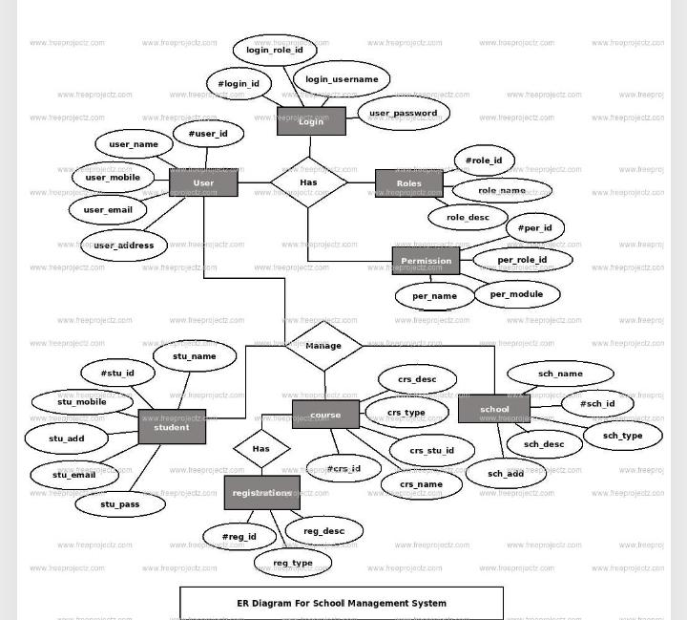
2. E-COMMERCE

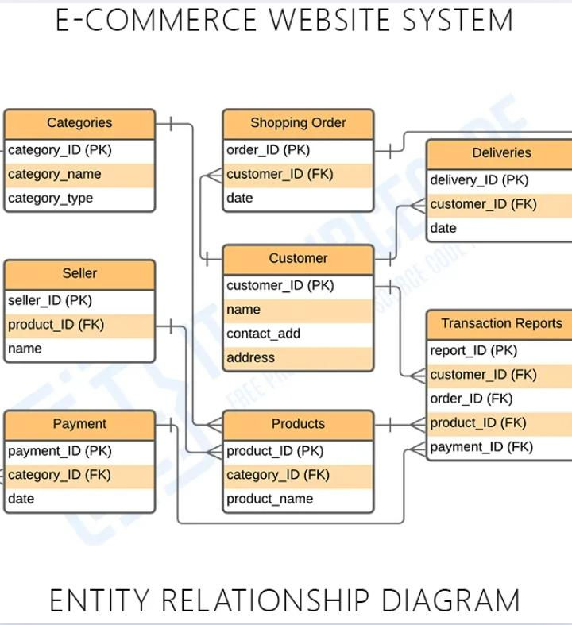

1. HOTEL MANAGEMENT

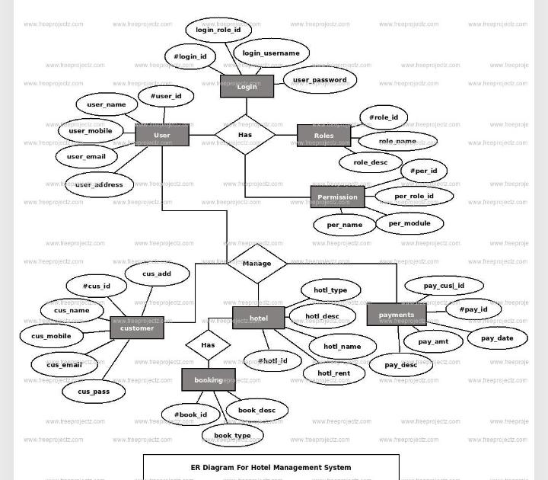

**Q - 7 : EXPLAIN VIEW WITH EXAMPLE.**

<https://www.geeksforgeeks.org/sql-views/>